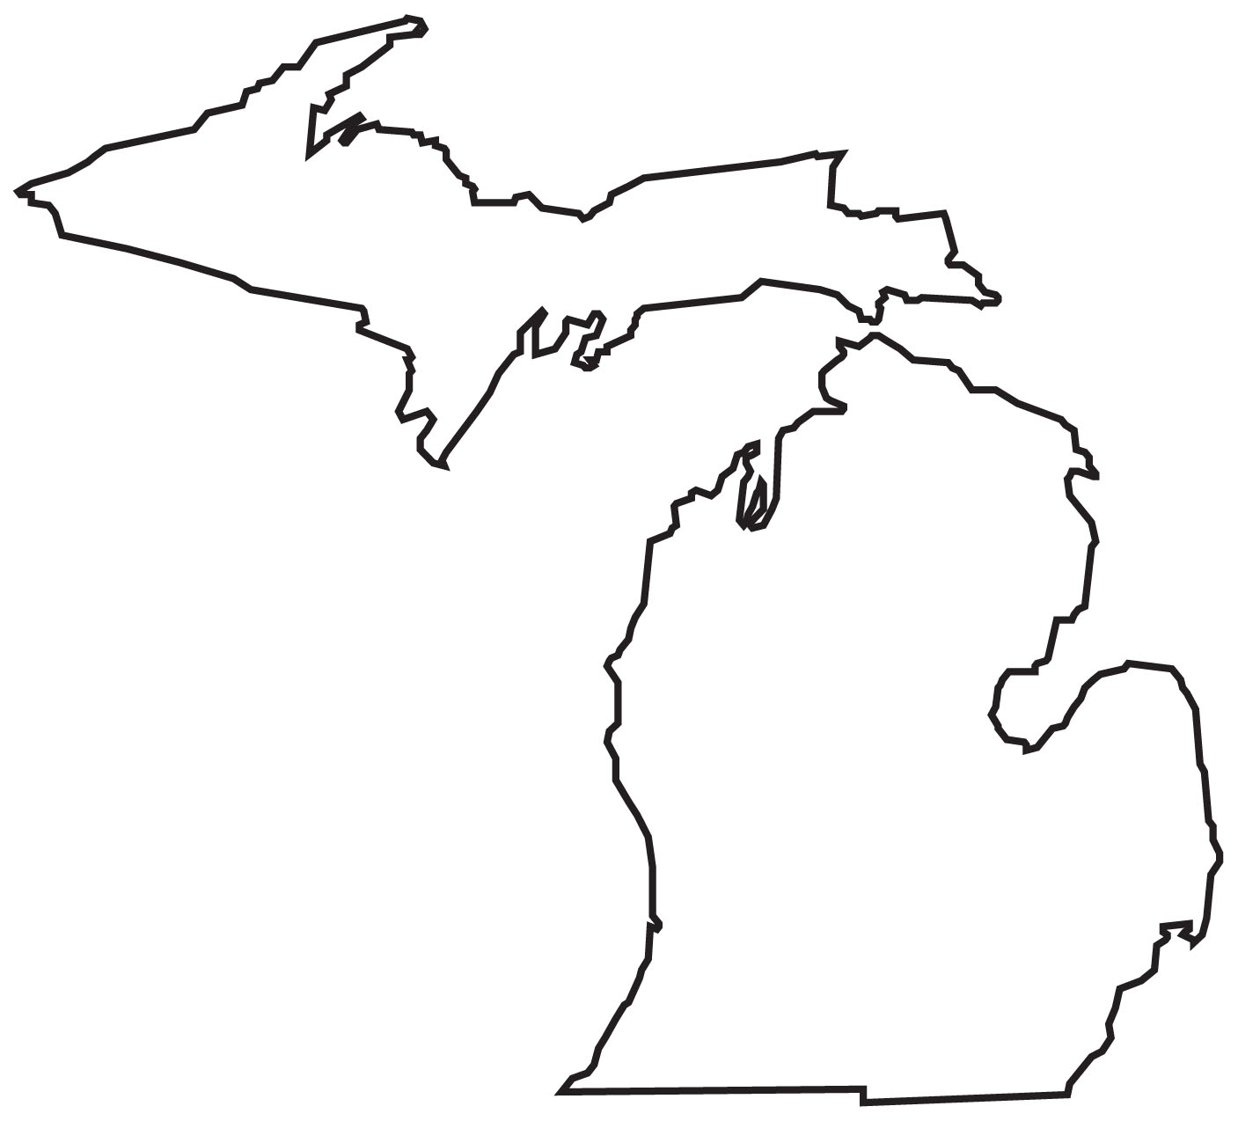
Lake Michigan CONFERENCE
Spectator Guidelines & Expectations

Member schools of the Lake Michigan Conference agree to work together in providing consistency in the promotion of good sportsmanship and respect toward opponents and game officials. The following are expectations that will guide the student bodies and spectators at all Lake Michigan Conference middle school and high school contests.

If spectators are standing, feet must be up on at least the first row of the bleachers. If feet are on the playing floor (front row), spectators must be seated at all times. Schools may allow students to stand at their own discretion. If spectators complain that they cannot see and one student body is required to be seated, both student bodies are to be seated, and remain seated. Student bodies are never to “rush the floor” following contests for any reason. Coaches should direct teams to the locker room immediately following the team handshake to help prevent such congregations, chants, etc.

Acceptable cheers:

“Defense! Defense! Defense!”

“Let’s go (school or nickname)!”

“He’s/She’s a Freshman (Sophomore, or whatever)!”
…as long as it’s for your own team & not retaliatory.

“Here we go (school or nickname)….”

“Go (School Color)…..Go (other school color)”

“I believe…..”
Any other cheers that place emphasis on cheering for your own team and not against the opponent.

If spectators of the opposing team are not adhering to these expectations, that does not make it acceptable for our team’s spectators to cheer inappropriately. Maintain appropriateness and be the better sports…represent yourselves, your school, and your community with pride, class and respect.

Unacceptable actions:

Anything with “you” or other terms that single out an opponent, including but not limited to:
“You can’t do that”
“You, you, you”
“Airball”
“Back to basics”
“Nah Nah Nah Nah, Hey, Hey, Hey, Goodbye”
“Overrated”
“Season’s Over”

“Nuts and bolts, nuts and bolts, we got …”

“Warm up the bus”

Turning backs, holding up newspapers or chanting “who cares!” during announcement of starting lineups

Waving arms or screaming during a foul shot

Any reference to degrade another sport of an opponent

Throwing of any object

Lake Michigan CONFERENCE
Spectator Guidelines & Expectations

It will never be acceptable to allow students (or any spectators for that matter) to berate game officials by pointing at them, screaming, swearing or demonstrating negative gestures or chants. We often fail to realize that these are fellow human beings who enjoy working with the student-athletes that are taking part in the contest. Spectators have no right to berate them or continually question calls. Let them do their job and allow them to officiate to the best of their ability. Additionally, we need to remember that the officials will be rating the schools for their sportsmanship and conduct during games.

Cheer loudly and positively for YOUR team. Be the type of person to congratulate the opponent or official on a good play, call, or game performance. If you have nothing good to say…in the spirit of good sportsmanship in high school sports…keep it to yourself.

What Is Sportsmanship?

sports'man ship' (n.) the practice of playing fair, of taking loss or defeat without complaint or victory without gloating, and treating opponents with fairness, generosity, courtesy, etc.

Sportsmanship is a demonstration of generosity and genuine concern for others. It is a concrete measure of the understanding and commitment to fair play, ethical behavior and integrity.

Sportsmanship is a blending of cheers for "your team" and applause for the "opponents," observing the letter and spirit of the rules, and showing consideration for others.

Sportsmanship is the "golden rule" of athletics - treating others as you wish to be treated.

Sportsmanship is respect. Respect for others and for one's self.

Sportsmanship is all this and much more.

For a coach, sportsmanship may be accepting a "questionable" call without protest.

For an athlete, it may be extending a helping hand to an opponent who is down.

For a general spectator, it may be cheering for his team when it loses, and applauding the opponent when it wins.

For an official, it may be showing restraint when verbally assaulted by coaches, athletes and spectators.

For parents, it may be avoiding living their lives through their children’s sporting activities

Sportsmanship encompasses all that which is good in human nature.

Sportsmanship is citizenship in action.

Sportsmanship is a way of life.
Lake Michigan CONFERENCE
Spectator Guidelines & Expectations

What Is Good Sportsmanship?

Good sportsmanship is viewed by the National Federation of State High School Association as a commitment to fair play, ethical behavior and integrity. In perception and practice, sportsmanship is defined as those qualities which are characterized by generosity and genuine concern for others:

• Play fair, take loss or defeat without complaint, or victory without gloating
• Treat others as you wish to be treated
• Respect others and one's self
• Impose self-control, be courteous, and gracefully accept results of one's actions
• Display ethical behavior by being good (character) and doing right (action)
• Be a good citizen.

Lake Michigan CONFERENCE
Fundamentals of Sportsmanship

Every year the MHSAA has been emphasizing the importance of good sportsmanship. Many people have not had good sportsmanship explained to them. The following six steps will help those people to understand their responsibilities at an athletic contest.

1. Gain an Understanding and Appreciation for the Rules of the Contest.

The necessity to be well informed is essential. Know the rules. If you are uninformed, refrain from expressing opinions on the officials, coaches, players, or administrative decisions. The spirit of good sportsmanship depends on conformance to a rule's intent as well as to the letter of a given rule.

2. Exercise Representative Behavior at All Times.

Good sportsmanship requires one to understand his/her own prejudices that may become a factor in his/her behavior. The true value of interscholastic competition relies on everyone exhibiting behavior which is representative of a sound value base. A proper perspective must be maintained if the educational values are to be realized. Your behavior influences others whether you are aware of it or not.

3. Recognize and Appreciate Skilled Performance Regardless of Affiliation.

Applause for an opponent's good performance displays generosity and is a courtesy that should be regularly practiced. This not only represents good sportsmanship, but reflects a true awareness of the game by recognizing and acknowledging quality.

4. Exhibit Respect for the Officials.

The officials of any contest are impartial arbitrators who are trained and who perform to the best of their ability. Mistakes by all those involved in the contest are a part of the game. We should not rationalize our own poor or unsuccessful performance or behavior by placing responsibility on the officials. The rule of good sportsmanship is to accept and abide by the decision made. This value is critical for students to learn for later application in life.

5. Display Openly a Respect for Opponents.

Opponents are guests and should be treated cordially, with thoughtfulness, be provided with the best accommodations, and accorded tolerance at all times. Be a positive representative for your school, team and family. This fundamental is the Golden Rule in action.

6. Display Pride in your Actions at Every Opportunity.

Never allow your ego to interfere with good judgment and your responsibility as a school representative. Regardless of whether you are an adult, student, player, coach, or official, this value is paramount since it suggests that you care about yourself and how others perceive you.

Lake Michigan CONFERENCE
Sportsmanship Traits

Courage is having the determination to do the right thing even when others don't; the strength to exhibit fairness, to be courteous, to gracefully accept the result of the contest, to attempt difficult things that are worthwhile.

Good Judgment is choosing worthy goals; setting priorities in accordance with team, county, state and national rules; leading others to follow these rules.

Integrity is having the inner strength to be fair and courteous during athletic events, to play according to the rules, acting positively and honorably not only to your team, but to your opponent.

Kindness is being considerate, courteous, and generous in spirit to the opposing team; showing care, compassion and friendship in victory or defeat; treating others as you would like to be treated.

Perseverance is being persistent in pursuit of worthy objectives in spite of opposition, difficulty, injuries, handicaps or discouragement, and exhibiting patience and the fortitude to try again when confronted with mistakes or failures.

Respect is showing high regard for coaches, officials, opponents, fans, administrators, self, team, and the school you are representing.

Responsibility is being dependable in carrying out obligations and duties, showing reliability and consistency in words and conduct, and being accountable for your actions.

Self-discipline is demonstrating hard work and commitment to purpose, regulating yourself for improvement and refraining from inappropriate behaviors, maintaining self-control at all times, and doing your best in all situations.

The Concepts of Sportsmanship
Sportsmanship is an oft-used word, yet no definitive explanation is readily available. We do know that it refers to some key concepts:

• Citizenship Values
• Competitive Integrity and Ethics
• Respect for Opponents and Officials
• Fair Play
• Understanding of the Rules
• Appreciation for all Performances
• Personal and Institutional Pride
• Gracious Acceptance of Results
• High Moral Character

