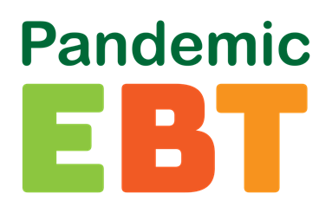 Important information for parents or guardians of student’s eligible for Free and Reduced Lunch at Sunrise Academy.

What is the Pandemic-EBT Program?
The Pandemic-EBT (P-EBT) Program gives food benefits to families with children who were not able to get free or reduced-price school meals due to COVID. You may hear about this benefit from other schools or in the media.

Who is eligible?
Being eligible for this program will depend on what school your student attends. Eligibility for the Pandemic-EBT (P-EBT) Program can be different between schools within the same district.

What makes a school eligible for P-EBT?
A school building is eligible only if the building has had 5 school days in a row of reduced in-person hours due to COVID.

What could make my student eligible for P-EBT?
1) If the school they attend is eligible for P-EBT and
2) If your student normally gets free and reduced meals at school and
3) If your student is not getting instruction in-person for some or all the month.

The Michigan Department of Health and Human Services (MDHHS) issues P-EBT benefits based on:
•How each school building reports their eligibility
•How most of the students attend school during the month

There may be months when your student’s attendance was different from what the school reported. In that case, you may be able to have your student’s benefit level reconsidered. Your request to be reconsidered must be submitted by June 30, 2021. In the month(s) below your school reported primarily in-person. Your student(s) may be P-EBT eligible if they attended class on-line, for some time or all the time in the following month(s):

October 2020 and January 2021

For more information, visit Michigan.gov/PEBT or call 1-833-905-0028.

