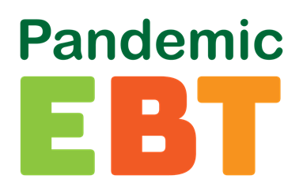 Important information for parents or guardians of student’s eligible for Free and Reduced Lunch at Elk Rapids High School.

What is the Pandemic-EBT Program?
The Pandemic-EBT (P-EBT) Program provides food benefits to families with children who were not able to get free or reduced-price school meals due to COVID. You may hear about this benefit from other schools or in the media.

Who is eligible?
Being eligible for this program will depend on what school your student attends. Eligibility for the Pandemic-EBT (P-EBT) Program can be different between schools within the same district.

What makes a school eligible for P-EBT?
A school building is eligible only if the building has had 5 school days in a row of reduced in-person hours due to COVID (closures due to staffing shortages do not count for P-EBT benefits).

What could make my child eligible for P-EBT?
1) If the school they attend is eligible for P-EBT and
2) If your student has applied and been approved for free/reduced lunch and
3) Did not receive instruction in-person for some or all the month due to COVID-19 related absence There may be months when your student’s attendance was different from what the school reported. In that case, you may be able to have your student’s benefit level reconsidered. Your request to be reconsidered must be submitted by June 30, 2023. In the month(s) below your school reported primarily in-person. Your student(s) may be P-EBT eligible If your student Did not receive instruction in-person for some or all the month due to COVID-19 related absence in the following month(s):

September 2022, October 2022, November 2022, December 2022, January 2023, February 2023, March 2023, April 2023, and May 2023

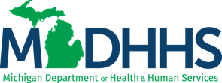
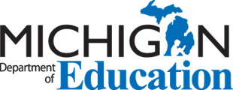
For more information, visit WWW.MICHIGAN.GOV/PEBT or call 1-833-905-0028.

