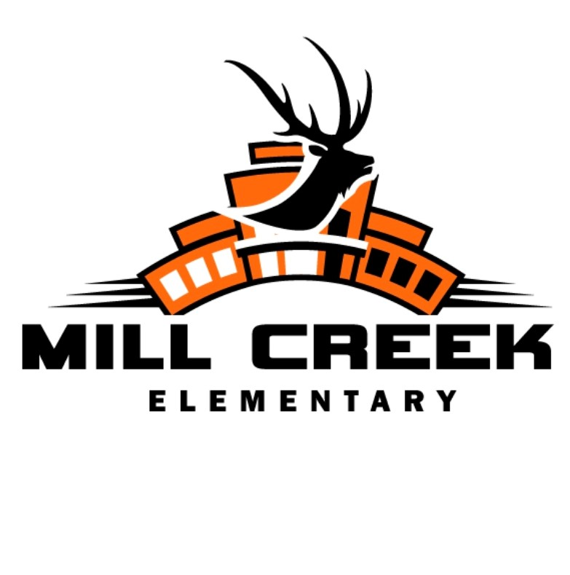
January 29, 2020
We are a community of learners inspired by our world.

Brett Graham, Principal bgraham@erschools.com

Dear Parents and Community Members:

We are pleased to present you with the Annual Education Report (AER). This provides key information on the 2018-19 educational progress for Mill Creek Elementary. The AER addresses the complex reporting information required by federal and state laws. The school’s report contains information about student assessment, accountability, and teacher quality. If you have any questions about the AER, please contact me for assistance.

The AER is available for you to review electronically by visiting the following web site (www.erschools.com) or you may review a copy in the main office at your child’s school.

For the 2018-19 school year, schools were identified using definitions and labels as required in the Every Student Succeeds Act (ESSA). A Targeted Support and Improvement (TSI) school is one that has at least one underperforming student subgroup. An Additional Targeted Support (ATS) school is one that has a student subgroup performing at the same level as the lowest 5% of all schools in the state. A Comprehensive Support and Improvement (CSI) school is one whose performance is in the lowest 5% of all schools in the state or has a graduation rate at or below 67%. Some schools are not identified with any of these labels. In these cases, no label is given.

Mill Creek Elementary School was identified as not having a label at this time.

Through a continuous improvement plan, Mill Creek continues to focus on student
achievement and research-based instructional practices. Elk Rapids Schools utilizes
research-based resources in reading and mathematics that were adopted district-
wide in 2017. ERS also utilizes a Response To Intervention model in mathematics
and reading which focuses on bridging the gaps for identified students. Our district
utilizes benchmarking data via NWEA and AIMSweb Plus in the areas of mathematics
and reading and also progress monitors students throughout the school year.
Mathematics continues to be an area of continuous academic focus.

Our teaching staff is currently working within a three-year commitment to utilizing
formative assessment data, success criteria and summative assessments to improve
student capacity in mathematics and all curricular areas.

Assigning Pupils to Our Building: Elk Rapids Schools assigns students to the appropriate school based on their grade level, needs, and residential address. In addition, Mill Creek participates in the Traverse Bay Area region “Schools of Choice” program and accepts out-of-district transfers in grades where space is available. For more information about student transfers, please contact the superintendent’s office at 231-264-8692.

Status of the School Improvement Plan: Elk Rapids Schools takes seriously the school improvement planning process as identified by the Michigan Department of Education. A district Curriculum Committee meets regularly and collaborates with staff, parents and the Board of Education Curriculum Committee. For 2015-16, the improvement goals included:
Goal 1: Improve student achievement in Math
Goal 2: Improve student achievement in English Language Arts
Goal 3: Improve student achievement in Science
Goal 4: Improve student achievement in Social Studies

Description of Specialized Schools: Elk Rapids Schools currently has Sunrise Alternative High School within our district. This alternative setting provides quality education for eager high school students. Additionally, we are in cooperation with Traverse Bay Intermediate School District to provide educational opportunities in the areas of center-based special education programs, as well as, career and technical education.

Access of Core Curriculum and Description of Implementation: The Michigan Common Core State Standards continue to be the driving force behind our curricular organization. Mill Creek’s Curriculum Guide may be made available to indicate state standards as well as additional skills that will be taught. This map communicates both the horizontal and vertical alignment of our curriculum. This and more curricular information can be obtained from me.

Percentage of Students Represented By Parents at Parent-Teacher Conferences:
Fall Spring
2016-17 95% 94%
2017-18 93% 92%
2018-19 95% 92%

Student Achievement Results:
As required by the state of Michigan, over the last two years students in grades 3-5 take MSTEP in the curricular areas of math and language arts. Proficiency levels are reported as the following:

2018-19 M-Step Proficiency Data
Grade | MC ELA | State ELA | MC Math | State Math | MC SS | State SS
3rd | 60.9% | 45.1% | >80% | 47% | NA | NA
4th | 65.4% | 46% | 65.4% | 42% | NA | NA
5th | 75.9% | 46% | 48.3% | 34% | 17.8% | 17.4%

Elk Rapids Schools continue to lead the way in educational excellence as one of the top schools in Michigan and the Regional School of Choice for our area. What allows such success to be achieved? Great teachers, outstanding students, caring, committed families, a supportive community and a Board of Education that puts children first in all they do. We are devoted to our students and their growth-both intellectually and emotionally.

We will continue to move forward and always look to improve the opportunities for our students. The future certainly looks bright at Elk Rapids Schools!

Sincerely,

Brett Graham, Mill Creek Elementary Principal

9039 Old M-72 Williamsburg, MI Phone 231-267-9955 Fax 231-267-5215

